Fall 2017 Campus Sustainability Fund Proposal
Trailers for Construction of Microcampers by
Spring 2018 Sustainability Capstone Students
Project Leader: Deborah Naybor
dnaybor@paulsmiths.edu, office phone 327-6254
Funds Requested: $1297

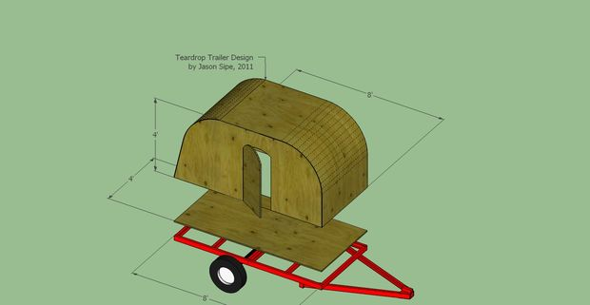
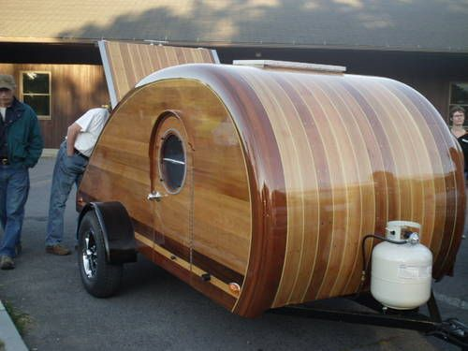

Project Summary
Goals Sustainability capstone students will use the knowledge they have gained during their course of studies to examine sustainable housing solutions on a small scale. They will design and build microcampers, small transportable units which have sleeping and food preparation space. The practical experience of taking a project from design stage to completion will provide goal setting, problem solving and teamwork capabilities. Students will learn sustainable methods through salvaging materials for construction of the campers and project management through the planning, design and construction.
Project Justification and Relevance - Tiny houses are in the news these days. There are magazines, blogs and TV shows discussing the how, why and where to jump into the tiny house lifestyle. Paul Smith’s College students have an interest in sustainable, affordable housing both from a personal opportunity and environmental standpoint. Building a complete tiny house is difficult in one semester for a capstone project, which has certain academic requirements. A smaller building project that incorporates the same skills will provide the maximum educational experience for the limited time allotted. The design will include learning to work within a budget, with a weight limit and within a limited timeframe, teaching management and entrepreneurial skills as well.
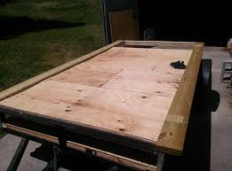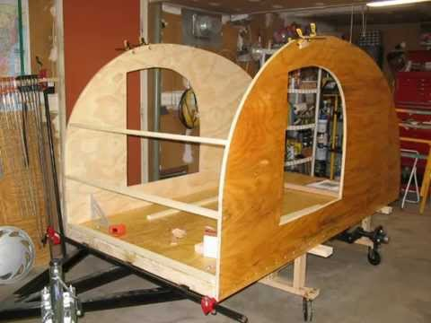
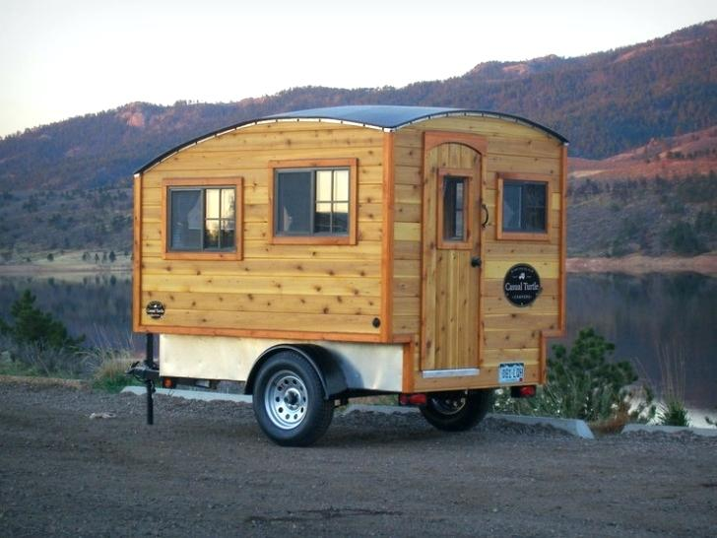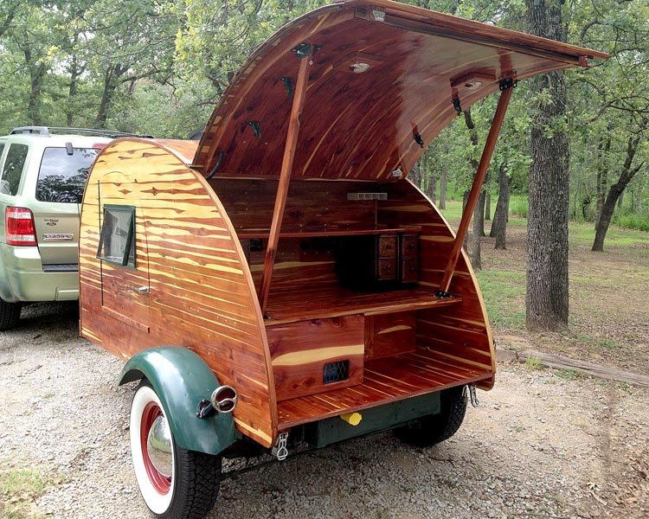
(Photos are examples only. Students are required to research and design microcampers as part of the class)
Methods
With 12 to 15 students expected in the class, it would be advantageous to build two microcampers based on two winning designs among the class members. Material for construction of the camper will be salvaged as much as possible but trailers, due to safety concerns, should be bought new. The first two weeks of the capstone class will be spent researching, planning and finalizing individual designs. Each design will be scored by the class on (a) sustainability factors (b) fit to criteria of weight, cost, size, etc. (c) practicality of completion time (d) function of use. Each winning preliminary design will be taken to the final design phase by a crew. Each crew which will develop a work plan and time schedule for completion by capstone presentation date.
Additional materials which cannot be salvaged may require a second CSF grant in Spring 2018 (or will be completed with the use of the instructor’s Professional Development Funds) but the total needed is estimated to be less than a total of $300 additional for two campers. All tools will be provided by the instructor and no tools will need to be purchased for this project. Tools available include (but are not limited to) hammers(5), screwdrivers (lots), circular saws (2), drills (4), chop saw (1), hand saw (2), levels (2), measuring tapes (4), paint brushes (6) and caulking guns (2), all of which are readily available from the instructor. Students will also be required to provide their own safety glasses and encouraged to bring their own hand tools.
With two completed microcampers, one can be either raffled, auctioned or sold while one could be kept as a showcase piece for perspective students and special events such as Homestead Festival. Funds from the sale of trailer (or trailers) would be used to purchase tools and materials for development of a Tiny House Construction class in Spring of 2019 (subject to administration approval). Estimated sale price would be $1000 to $2000 per camper depending on size, materials and interior finish.
Trailers will be constructed in one of the Tomkins garage bays after canoes are moved to canoe storage building and trailer is moved outdoors. This has been coordinated with Bobby O’Connor, Brett Mcleod and approved by Karen Edwards, department chair (see letter).
The completed microcamper(s) will be moved out of the Tomkins garage before the end of semester and sold. If administration approves keeping one microcamper, it will be moved to the VIC with an informational sign or covered and stored outdoors in an approved location. If no location for storage can be found, both will be sold at commencement.

Project Budget and Timeline
Budget Item | Cost per trailer* | Total (2)
Trailer | $529.99 | $1059.98
Shipping | $118.35 | $236.70
Total | $648.34 | $1296.68
*2 trailers is preferable but if funding is only available for 1, we will adjust the class accordingly

Timeline
Approval of funding from Campus Sustainability Fund, trailers will be purchased during winter break. Students registered for the class will be given a list of needed materials at the end of Fall 2017 term so that they can salvage as much as possible over the break. In Spring 2018, the microcampers will be designed during the first two weeks of the course, construction will begin on week three and will be completed by May 4, 2018 for Capstone presentation so that they can be displayed as part of the students’ presentation. Sale, raffle or auction will happen at commencement weekend.
Sample Microcamper plan (students will design campers which are appropriate to budget, skill level and timeframe available)
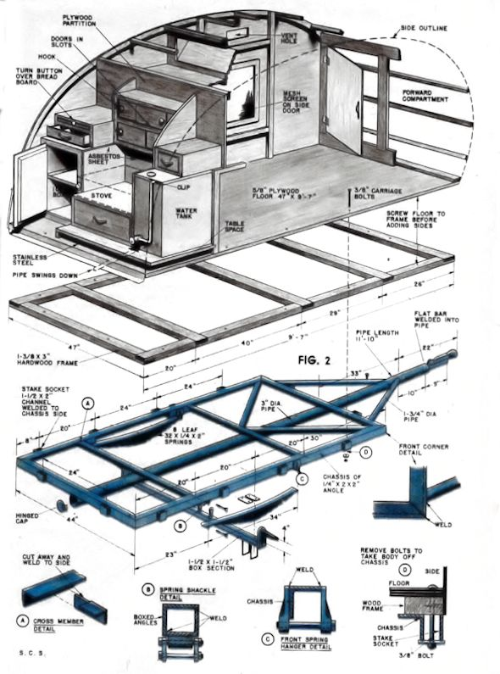
Workplan for SUS 496, Spring semester 2018
Dec 2017 – Pre- Course Meeting – Students enrolled in SUS 496 will meet prior to the end of Fall 2017 semester and will be provided with a list of materials (lumber, windows, hinges, etc.) which can be salvaged over winter break. Currently, PSC alumni are also salvaging materials and will bring them to the college prior to the start of the semester.
Spring Semester 2018
Week 1 – Introduction to capstone, lecture on the social, economic and environmental contributions of micro housing, sustainable design and building, tool safety training. Students will form two design/construction teams. Research on dept. of transportation requirements.
Week 2 – Sketch up software training for design, lecture on the physics of mobile housing,-submission and presentation of multiple design plans, project management plan developed including final budget after accounting for salvaged materials, timeline, weight calculations and feasibility study.
Week 3 – Design calculations and development of final construction plans, construction of trailer floor, inventory existing materials and create a list of remaining needed materials. Students will raise additional funds if necessary.
Week 4 –Gather and cut materials for wall construction, verify and adjust plans as needed, perform literature review on sustainable, micro and mobile housing
Week 5 – Assemble sidewalls, presentation of findings from lit review
Week 6 – Install front and back walls, construct support for roof, reading and discussion on salvaged and locally sourced materials, verify weight to date.
Week 7 – Capstone Requirements lecture, draft of introduction and methodology sections, verify opening sizes and install windows.
Week 8 – Construct roof, Verify or adjust project timeline, revisit needed materials list and weight limit. Draft presentation slides due.
Week 9 – Construct door, lecture on interior design, measure and create plans for interior. Student presentations on progress and problems.
Week 10 – Create capstone posters. Install door. Draft 1 of final paper due.
Week 11 – Finish exterior shell, seal and caulk. Practice capstone presentation.
Week 12 – Capstone presentation. Trailers will be parked outside of the Library with posters on display showing the sustainability aspect, design and construction process for the project. Students will work in teams of two people to explain the posters and demonstrate the use of the trailers.
Week 13 – Complete interior. Debrief process and create a best practices manual and a list of suggested improvements.
Week 14 – Final portfolio due including final group paper, individual self evaluations, and photo journal.
Note: all learning objectives in MCO will be met and assessed.

Appendix
Letter from Environment and Society Department Chair
To: Campus Sustainability Fund Committee
From: Karen Edwards
Department Chair,
Environment and Society
Re: Sustainability Capstone Project Request
Made by Deb Naybor
Date: 10/25/17

I would like to support Professor Deb Naybor’s application for funds to help her put together a unique Capstone for our Sustainability Capstone students. She has the support of the Environment and Society department and has gotten permission to use the recreation garage bays at Tompkins. She and her students intend to build two micro-campers, providing the hands on experience that we are committed to at Paul Smiths. The students will put sustainability ideals into practice.
These campers will provide a very visible stamp on our program, highlighting our continuing commitment to the many facets of sustainability on this campus. If I can provide any more details you might need feel free to contact me.

Sincerely,

Karen Edwards

Current MCO for Sustainability Capstone
Course Title | Sustainability Studies Capstone
Course Description | Provides the opportunity for Sustainability Studies students to integrate their knowledge and experiences related to Sustainability Studies and their exposure to the liberal arts to: (a) demonstrate mastery of the general education core and programmatic learning objectives; and (b) engage in projects in the areas of applied sustainability science and service to the community – based on project directions discussed and groundwork laid during SUS 496. In addition, students are expected to broaden their understanding and application of skills and knowledge developed in courses leading up to the Capstone, such as literature review techniques, research methods, study design, and effective communication of information.
Course Objectives: | Design and produce a culminating experience and articulate ethical implications and the social, cultural, economic, or scientific rationale.  Gather, analyze and synthesize appropriate information. Students will access, critically review and properly credit appropriate and current primary resources in their discipline.  Communicate effectively in an academic and/or professional setting in both written and oral modes.  Assess one’s own academic and/or professional abilities and limitations. Integrate the Paul Smith's College education with the challenges and opportunities facing society and/or the environment.  Incorporate a respect for others’ values and ideas while using a broadened perspective in their approach to problem solving  Express an understanding of fundamental research concepts, including: relationships among research, knowledge, and science  Express an understanding of fundamental research concepts including differences in approaches to and methods appropriate for both social and biophysical sciences  Express an understanding of fundamental research concepts including language appropriate to scientific expression.
Course Resources: | Kuhn. T. 1962. The structure of scientific revolutions. University of Chicago Press.  Egan, A. 2001. Scientists, truth, and the media: A clearcut issue. Journal of Forestry. 99(2):48.
Course Development Resources:
Assessment Instituional Improvement: | Copies of the Capstone Project Reports, project evaluations, and the Graduation Candidacy Applications will be stored by the Library archive system and the Registrar, respectfully.
Required Courses:
Restricted Electives:
Student Feedback Assessment: | ♣ Attendance and participation in class ♣ A test on scientific and professional discourse and attributes of scientific investigation ♣ A written project report ♣ Oral project defense in the form of a powerpoint or poster presentation In addition, students will complete a Graduation Reflection Assessment that will provide an opportunity for students to map their Paul Smith's College experience and identify the tools that they have developed to continue their lifelong learning experience.
Literacies:
Course Area: | SUS
Course Level: | 400.0
Credit Hours: | 3.0
Contact Hours: | 3.0
Contact Hour Rationale:
Gen Ed Approval Date: | 2009-03-01
Part of Gen Ed Date: | 0
IGE Status Pending:
MCO Last Review: | 2009-01-01
MCO Accurate: | 1
IGE Rationale: | Capstone
Liberal Arts: | 0
Pre/Co Requisites:
Critical Content: | What are research, science, knowledge, collaboration, respect, humility, skepticism in the context of scientific inquiry and how are they different from advocacy, opinion, consensus? o What are the biophysical and social science dimensions of and approaches to research and research methodology? o What are the values, dimensions, and opportunities for community service in the area of Sustainability Studies? o What are modes and guidelines for professional and scientific discourse – both written and oral?
Division of Record: | FNRR
Instructor of Record: | New Faculty

Trailer specifications

Ironton 5ft. x 8ft. Heavy-Duty Utility Trailer Kit — 1715-Lb. Load Capacity -
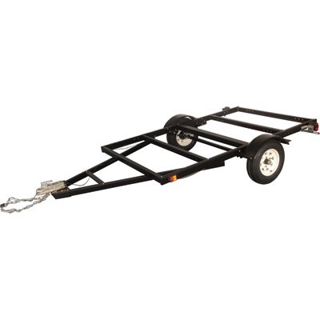

- 136in.L x 76in.W overall size with 1715-lb. payload capacity
- Rolls smoothly on two 5.30-12in. tires with protective fenders to prevent rocks and debris from damaging your cargo
- Includes safety chains and light kit so you can hit the road immediately
- 2in. coupler assembly and wiring harness connect to your vehicle to ensure trailer safety on the road, even in dark or rainy conditions
- Customizable steel deck area to handle large loads
The Ironton® 5ft. x 8ft. heavy-duty trailer kit has a large, customizable 96in. x 60in. steel deck area (decking not included) to handle big loads. 1980-lb. max. GVWR. Meets or exceeds all road-ready specifications and DOT requirements. Assembly required.
Key Specs
Item# | 37552
Brand | Ironton
Manufacturer's Warranty | 1 year Limited Warranty
Ship Weight | 273.9 lbs
Gross Vehicle Weight Rated (lbs.) | 1980
Load Capacity (lbs.) | 1,715
Deck Size L x W (ft.) | 5 x 8
Wheel Size (in.) | 5.3 - 12
Coupler Size (in.) | 2
Deck Material | Steel
Frame Material | Steel
Brakes | No

To: Campus Sustainability Fund Committee
From: Karen Edwards
Department Chair,
Environment and Society
Re: Sustainability Capstone Project Request
Made by Deb Naybor
Date: 10/25/17

I would like to support Professor Deb Naybor’s application for funds to help her put together a unique Capstone for our Sustainability Capstone students. She has the support of the Environment and Society department and has gotten permission to use the recreation garage bays at Tompkins. She and her students intend to build two micro-campers, providing the hands on experience that we are committed to at Paul Smiths. The students will put sustainability ideals into practice.
These campers will provide a very visible stamp on our program, highlighting our continuing commitment to the many facets of sustainability on this campus. If I can provide any more details you might need feel free to contact me.

Sincerely,

Karen Edwards

