PSC Draft Horse Club Horse Trailer Proposal
Spring 2020 Campus Sustainability Grant Application
Proposed By:
Madeline Roth, Draft Horse Club President
Tom Curiale, Draft Horse Club Secretary
Addy Balliett, Draft Horse Club Treasurer
Participants Include:
Lydia Wright, Draft Horse Club Advisor
Allie Lamb, Draft Horse Club Member
Max Dentone, Barn Hand & Draft Horse Club Member
Caleb Cempa, Barn Hand & Draft Horse Club Member
Paul Smith’s College Draft Horse Club
Sara Dougherty, Barn Manager & PSC Draft Horse Club Advisor
Email: sdougherty@s.paulsmiths.edu
Phone: (315)317-8071
Total Amount Requested: $5,000.00
Request for Funding:
Abstract: Recently it has been brought to our attention that the college’s horse trailer is getting unsafe for transporting our current team of horses (Dana and Dodge). A horse trailer is a necessary implement for owning and caring for live animals. Trailers are used for emergency transportation, events, and for regular transport between campus facilities.
Purpose Statement: The purpose of this proposal is to (1) procure funding necessary to purchase a newer horse trailer for our team, (2) increase the financial sustainability of the PSC Draft Horse Program, and (3) enable the college draft horses to be utilized by multiple academic departments in off-site educational programs, intercollegiate events, logging / agricultural demonstrations, and community outreach initiatives.
Goals:
- Obtain Equipment – purchase a horse trailer that will fulfill the need to safely transport the college draft horses to off-site destinations.
- Promote localized carbon neutral agricultural practices – help Paul Smith's College Draft Horse Program promote sustainability by demonstrating low impact, carbon neutral farming methods both locally, and regionally.
- Educate students and the public at large by providing educational programs and demonstrations of techniques and implications of animal power both in woodlot settings and in recreational events.
Impact Statement: The intended outcome of this proposal is to enable the PSC Draft Horse Program to safely transport the College Draft Horses off-site for use in educational programs, animal powered workshops, intercollegiate events, logging /agricultural demonstrations, and / or community outreach. Paul Smith’s College is one of very few higher education institutions that offer Draft Horse Programs as well as the distinction of having an established Draft Horse program in place for over four decades. Sustainable agriculture and the art of driving a team of draft horses, as done by our ancestors, has become somewhat of a lost art. As more college institutions embrace the concept of sustainable practices, the Paul Smith’s College Draft Horse Program, is in the forefront in regards to academic institutions. Utilization of the college draft horses in diverse programs, helps establish a wider range of use for this unique college resource. Currently, the limiting factor in allowing for off-site use of the college horses is our ability, or inability, to safely transport them from site to site. Currently, we are limited to having the horses travel short distances, in absence of a trailer (i.e. events on campus, VIC, Gould’s Garden, Osgood Farm, etc.).Having access to a horse trailer will enable this valuable asset to be utilized to their fullest potential. In the past, when we have had a safe trailer to use, the Draft Horse Club has participated in demonstrations and workshops through:
The Draft Animal Power Network /DAPNet
The Local Living Festival in Canton, NY
Draft Animal Workshops at The Farm School in Massachusetts
The French Canadian Exposition of Connecticut
Malone County Fair, Malone, NY
Saranac Lake Winter Carnival, Saranac Lake, NY
Draft Animal Plowing Workshops through DAPNet at We-Li-Kit Farm
DAPNet, as well as other private farms and organizations, have been quite vigilant in recruiting Paul Smith’s College students and folks from our Draft Horse Program to become more active in their associations/businesses. We have a well-established, successful draft animal program which many people in the draft animal world, consider a model for other academic institutions. Our goal is to have the ability to actively demonstrate and promote the use of draft horses in sustainable agricultural and woodlot practices, through events held by these organizations. Having a new horse trailer will enable the club to safely transport the PSC horses to various events hosted by these organizations.
Resources: Professor & Forestry Department Head, Brett McLeod and Barn Manager, Sara Dougherty have assisted in determining the appropriate size and style of horse trailer best suited to transport the College Draft Horses. Brett and Sara, have located several horse trailers available for sale, that are roughly $10,000.00 in cost. Both Sara and Brett have made contact with potential sellers to indicate our possible interest in purchasing their unit(s). If the potential unit(s) are no longer available when and if we are able to purchase, an appropriate substitute of comparable cost and value will be procured. In times past, the college has invested in steel bodied trailers. Due to the regional weather in the Adirondack Mountains, long harsh winters have caused significant decay of these style implements. Although they are costly, an aluminum body trailer is more rot-resistant and will last the college longer, in the event the Sustainability Committee decides to move forward with our grant proposal. Choosing to purchase an aluminum body trailer is a long-term and sustainable investment for both the club and institution.
Documentation and Permissions: It’s been determined that the Forestry Department and PSC Facilities will oversee the maintenance and registration of the horse trailer. David Simmons and Mike Reardon would be responsible for documentation & storage of the horse trailer. In addition, requests for its use will be handled by Jeff Walton, Brett McLeod, & Sara Dougherty.

Budget:
Stock 2 Horse Slant Load Horse Trailer………………………………………………. $10,000.00
The additional $5,000.00 will be matched by the PSC Draft Horse Club Restricted Account, the PSC Forestry Restricted Account, and from PSC Alumni Gifts/Donations. These three groups have committed to assisting in the purchasing of a horse trailer (letters of intent are available upon request). This reduces the Campus Sustainability funding request to $5,000.00.
Timeline: Once a decision has been made in regards to funding, contact will be made with the seller to indicate our decision to purchase the 2 Horse Slant Load Horse Trailer. If the trailer is still available for purchase at that time, arrangements for payment will be made and a trip to collect the trailer will be scheduled. Both Brett and/or Sara have indicated that either would be willing to drive to bring the horse trailer back to Paul Smiths, once arrangements for its purchase have been secured. Our hope is to have the horse trailer bought and delivered to Paul Smith’s College by the beginning of Summer 2020 semester.
Outcomes: Again, Paul Smith’s College is one of a select few colleges that offers students the chance to participate in a Draft Horse Program, as well as the distinction of having an established, and active Draft Horse Club. The use of draft animals in Sustainable agricultural practices has seen a resurgence in the past several years and as a direct result, the Draft Horse Club has had an increase in requests for participation in draft animal power workshops, demonstrations, and events. With greater mobility, the club will increase its ability to participate in various regional draft animal power events with our draft horse team, in an effort to promote sustainable agricultural practices as well as market our college’s programs to prospective students. Success will be measured by the increase in the number of off-site events the PSC Draft Horses participate in and can be shared with the campus community through the Draft Horse Club/Program, Forestry Department, and the Campus Sustainability Office.

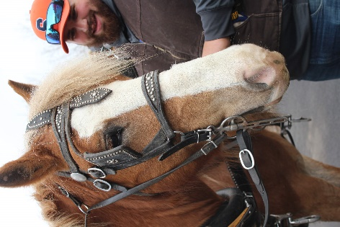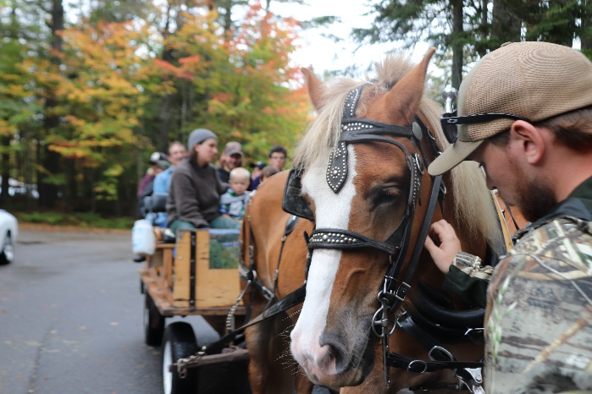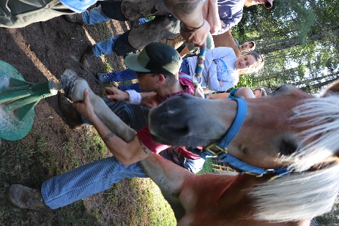
Thank You All for Your Time & Consideration!

