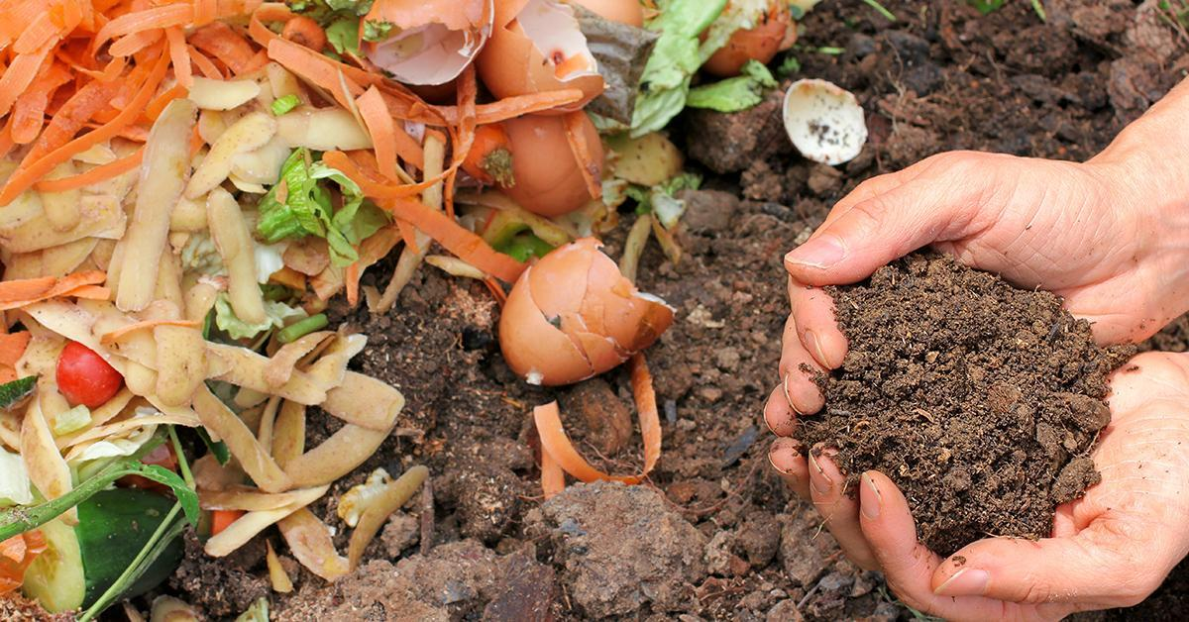

On-Campus Housing Composting Initiative
Fall 2019
─
Charles J. Ritter
Critter@paulsmiths.edu (814) 777-8505
Bethany Garretson, Emily Nelson, and Janey Rolfe
Total Requested: $485

Project Summary

Goals
To create a culture of sustainable waste management at the individual level within the Paul Smith’s student body. Furthermore, to promote the Paul Smith’s Sustainability Committee on the Paul Smith’s Campus.

Project Justification and Relevance
Currently Paul Smith’s College has a functioning composting program in the dining hall and in the culinary labs. This composting program has opened the doors to sustainable waste management on the Paul Smith’s College campus. However, many students living in the residence halls with a kitchen, whether private or communal, cook for themselves and are simply discarding compostable materials into the garbage. Since composting on campus is already available, we believe that making composting bins available for those living in dorms with a kitchen would be ideal. This type of on-campus composting system has proven to be successful at other universities such as University of Colorado: Boulder, University of Michigan, and Harvard University. Following similar practices used at the aforementioned universities, Paul Smith’s College will increase the overall sustainability on campus through education, outreach, and practical exercise.

Methods
To kickoff the composting initiative, the Fall 2019 grant money will be utilized to purchase individual five-gallon buckets and large garbage bins. The five-gallon buckets will be used at the individual level, while the garbage bins will be placed in communal kitchens and as a common collection point in residence buildings with private kitchens. In conjunction with the Sustainability Committee, each five-gallon bucket will feature the official Paul Smith’s College Sustainability Committee logo. This will increase the amount of outreach and public relations between the Sustainability Committee and the Paul Smith’s student community. No grant money will be put forth to pay additional work study hours in compost pickup and transportation. Greta Hovland, the manager of the current work-study student disposing and transporting the campus’ compost, has agreed to extend her work-study’s hours in order to make this project functional. The composting program will be entirely optional to students in order to minimize the amount of non-compostable material thrown into the compost as a result of indifference. Each bucket will come with a guide on composting basics, understanding what is and what is not compostable.
The future of the composting initiative relies on cooperation between multiple different departments on campus. Greta Hovland, head of the Dining Department, will oversee the pickup of the compost. The Residence Life and Housing Department, headed by Lou Kaminski, will work in conjunction with the Sustainability Committee to manage the overall composting program. I, personally, am able to head the composting initiative within the Sustainability Committee until I graduate in the spring of 2021.

Project Budget and Timeline

Budget

Item | Price Per Unit | Number of Units | Overall Price
5/gal bucket | $7.00 | 35 | $245
Lids for 5/gal bucket | $4.00 | 35 | $140
32/gal bin with lid | $20 | 7 | $120
 |  |  | Total: $
Thirty-five five-gallon units is an optimistic number for the amount of students in Upper/Lower and Overlook halls that are willing to participate in this program. However, I believe it is better to be optimistic rather than have a shortage of materials. Especially if this program continues to grow over the years. Seven larger thirty two-gallon units will be used throughout campus. One in Saratoga hall to cover their communal kitchen, and two unit in Upper/Lower and Overlook hall.

Timeline
Early December- Order the materials needed from affordablebuckets.com.
Prior to January 20th- Distribute the buckets to RA’s on campus for them to distribute to students willing to begin composting.
End of Term- RA’s to collect buckets during final room inspections. Buckets will then tentatively be stored by Residence Life and Housing Department.
Fall 2020 Term Beginning- Distribute the buckets to RA’s on campus for them to distribute to students willing to begin composting.

Supporting Documents

Greta Hovland, Director of Dining Services:
Approved, waiting on letter

Lou Kaminski, Director of Residence Life and Housing:
Processing still

