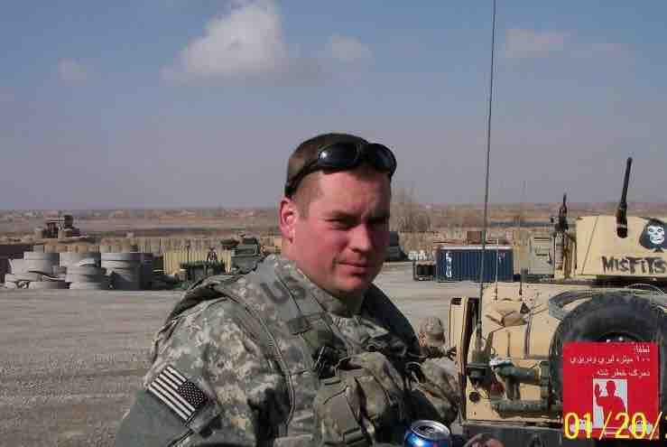
Mathew Powers Is a Decorated Infantry Combat Veteran who served with The 2/108th Infantry Battalion of the NY Army National Guard in Afghanistan. He is a Hero to his home town of Saranac Lake and to his family. Throughout his life, he has selflessly served others and he always strives for success. On January 16th 2017 he and his family lost their home on Lake St. in Saranac Lake due to an electrical fire that had started within the house. This comes at a time of the year that is very hard for all families here in the ADK's, however this is not just a hardship, it's sheer devastation for the Powers Family. Mathew and Cynthia have four children age 2,5,13 and 14.

Please Join the PSC Veterans’ Association in this fund-raising event as they work to support the Powers family. Every penny helps make a difference!
Details:

- The event will be held on 25 March 2017 in the college gymnasium during the admission’s open house

- Participants will have one hour to perform push-ups

- Those who are unable to perform pushups will be allowed to do sit-ups with the same guidelines

- Sponsors will donate a specified amount per push-up or a lump-sum

[ $ amount x number of push-ups]

- Sponsors do not need to be present

- 100% of the proceeds go to the Powers family.

*Sample Donations*
 | 10 PU | 50 PU | 100 PU | 200 PU | 300 PU | 500 PU | 1000 PU
$0.01 | $0.10 | $0.50 | $1 | $2 | $3 | $5 | $10
$0.02 | $0.20 | $1 | $2 | $4 | $6 | $10 | $20
$0.05 | $0.50 | $2.50 | $5 | $10 | $15 | $25 | $50
$0.10 | $1 | $5 | $10 | $20 | $30 | $50 | $100
Sample Donations:

By signing this form, I promise to fulfill my agreement to donate the listed amount per each push-up correctly performed by .

Sponsor’s Name Sponsor’s Signature
$0.01 $0.02 $0.05 $0.10 Other:
Push-Ups Completed: Amount Donated:

Sponsor’s Name Sponsor’s Signature
$0.01 $0.02 $0.05 $0.10 Other:
Push-Ups Completed: Amount Donated:

Sponsor’s Name Sponsor’s Signature
$0.01 $0.02 $0.05 $0.10 Other:
Push-Ups Completed: Amount Donated:

Sponsor’s Name Sponsor’s Signature
$0.01 $0.02 $0.05 $0.10 Other:
Push-Ups Completed: Amount Donated:

Sponsor’s Name Sponsor’s Signature
$0.01 $0.02 $0.05 $0.10 Other:
Push-Ups Completed: Amount Donated:
Contact svincent@s.paulsmiths.edu for additional information or with any questions or concerns

Sponsor’s Name Sponsor’s Signature
$0.01 $0.02 $0.05 $0.10 Other:
Push-Ups Completed: Amount Donated:

Sponsor’s Name Sponsor’s Signature
$0.01 $0.02 $0.05 $0.10 Other:
Push-Ups Completed: Amount Donated:

Sponsor’s Name Sponsor’s Signature
$0.01 $0.02 $0.05 $0.10 Other:
Push-Ups Completed: Amount Donated:

Sponsor’s Name Sponsor’s Signature
$0.01 $0.02 $0.05 $0.10 Other:
Push-Ups Completed: Amount Donated:

