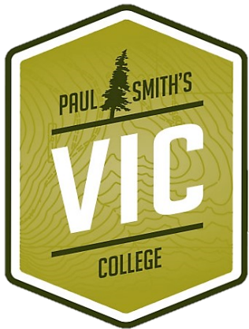
Jenkins Mountain Scramble!

Trail 10k
Saturday August 10th 2019
Paul Smith’s College Visitor Interpretive Center

Day of registration 8:30
Start 10:30

Pre-Registration (by 8/5/19) Day of Race
10k - $25 10k - $25
Half Marathon - $50 Half Marathon - $60

ONLINE REGISTRATION AT
https://events.eventzilla.net/e/10k-jenkins-mountain-scramble-2138743630
https://events.eventzilla.net/e/half-marathon-jenkins-mountain-scramble-2138745715

Check made payable to: PSC VIC (Donations are accepted and appreciated.) All proceeds will benefit recreational events at the VIC!
Please direct all questions to: tdezago@paulsmiths.edu

For mail-in applications, send to: PSC VIC 8023 State Route 30, Paul Smiths, NY 12970
Print Name: _______________________________________________________________
Street: _______________________________________________________________
City/ Town/ Zip Code: _________________________________________________________
E-mail: _______________________________________________________________
Age: ______ Sex: ______ Date of Birth: ____ / ____ / ____
Circle t-shirt size :
XS S M L XL
A limited number of Tee shirts will be available.

By Signing this waiver I hereby release the organizers, The Paul Smith’s College Visitor Interpretive Center, Paul Smith’s College, New York State, the sponsor, officials and landowners of any and all liability arising from my injury or death or loss of property during this competition which is an action sport posing significant risk.

Signature: _______________________________ Date: ____ / ____ / ____

Parent/ Guardian’s Signature: ______________________________________ (if under 18 years of age)

